**First Mother’s Day**

**RULES:** Practical Shooting Handbook, Latest Edition **COURSE DESIGNER:** Ike Starnes

|  |  |
| --- | --- |
| **START POSITION: See written stage briefings.** | |
| **STAGE PROCEDURE**  Engage targets from within the shooting area. | **SCORING**  **SCORING:** Comstock, 22 rounds, 110 points  **TARGETS:** 11 cardboard targets  **SCORED HITS:** 2 Best hits per carboard will be scored  **START-STOP:**  Audible - Last shot  **PENALTIES:** Mike -10, NS -10, Procedural -10 |

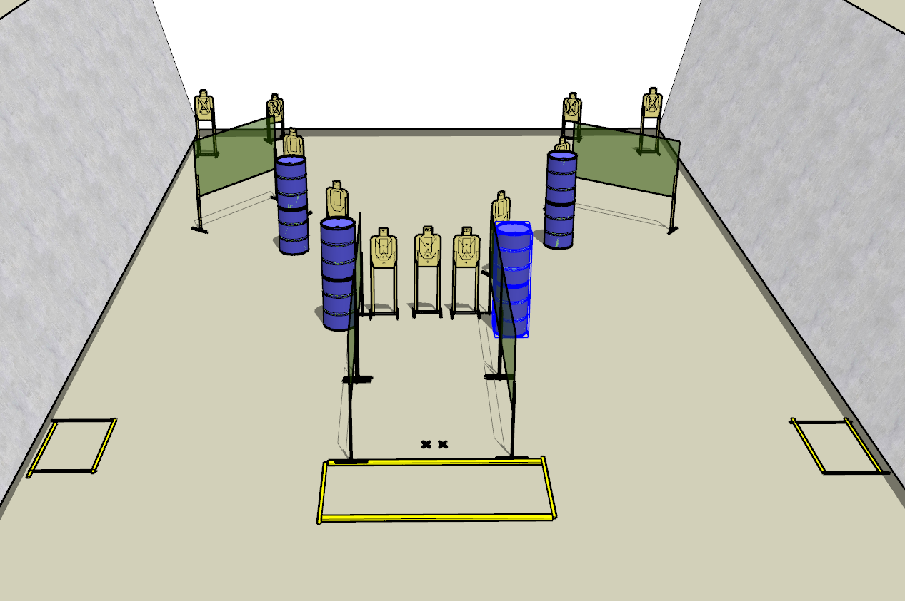

**Written Stage Briefings:**

**Stage 1 –** is a 22-round, 110 point, Comstock Long Course. There are 11 cardboard targets. The best 2 hits per cardboard target will be scored.

**Handgun start position** is standing with both feet inside the far-left shooting box with wrists below belt. The handgun is loaded and holstered.

**PCC start position** is standing with both feet inside the far-left shooting box. PCC is loaded with safety on and buttstock on belt with muzzle pointed downrange.

On the audible start signal, engage targets from within the shooting area.

**Stage 2 –** is a 22-round, 110 point, Comstock Long Course. There are 11 cardboard targets. The best 2 hits per cardboard target will be scored.

**Handgun start position** is standing with both toes on rear of the far-right shooting box with wrists above shoulder. The handgun is loaded and holstered.

**PCC start position** is standing with both toes on rear of the far-right shooting box. PCC is loaded with safety on, held in both hands, with wrists above shoulder and muzzle pointed downrange.

On the audible start signal, engage targets from within the shooting area.

**Stage 3 –** is a 22-round, 110 point, Comstock Long Course. There are 11 cardboard targets. The best 2 hits per cardboard target will be scored.

**Handgun start position** is standing with feet on Xs. The handgun is unloaded and holstered.

**PCC start position** is standing with feet on Xs. PCC is unloaded held in both hands and muzzle pointed downrange.

On the audible start signal, engage targets from within the shooting area.